AY15/16

Q4.

5V

CS VDD

VSS

SCK SI/O

Arduino UNO MCU

P3

P2

P1

P0

CS VDD

VSS

SCK SI/O

(10 marks)

1. No.

(1 marks)

1. 0.0625 degree per bit

(2 marks)

1. 2 bytes

(2 marks)

1. 30 deg/0.0625 = 480 bits = 0 0001 1110 0000

(4 marks)

1. Continuous Conversion mode is appropriate as there is no power consumption limitation when the car’s engine is on.

(3 marks)

1. 0000

(3 marks)

AY16/17

Q4)

1. Sketch a schematic circuit diagram to show a possible connection between an Arduino UNO MCU, the Allegro 3967 Microstepping Driver and a bipolar stepper motor.

7V

5V

UNO MCU

**PWR**

**8**

**7**

**6**

**5**

**GND**

3967

**14** VCC

**13** MS2 OUT 1A **16**

**12** MS1 OUT 1B **21**

**11** Dir OUT 2A **9**

**10** Step OUT 2B **4**

GND

**6 7 18 19**

(11 marks)

1. Driver’s highest resolution = 1/8 step

Total number of steps per revolution = 200 x 8 = 1,600 steps

Highest stepping resolution = 360/1,600 = 0.225°

(4 marks)

1. Write code in C++ to set up the Driver in Half Step mode.

digitalWrite(7, HIGH);

digitalWrite(8, LOW);

(2 marks)

1. steps_to_move = 200 x 2 [because half step] = 400

(2 marks)

1. stepPW = 1μs or higher, according to datasheet pg 7.

(2 marks)

1. Speed = 60 rpm = 1 rps = 400 steps / s

Step Delay = 1 / 400 = 2.5ms = 2,500 μs

stepDelay = 2500

(4 marks)

AY17/18

Q2)

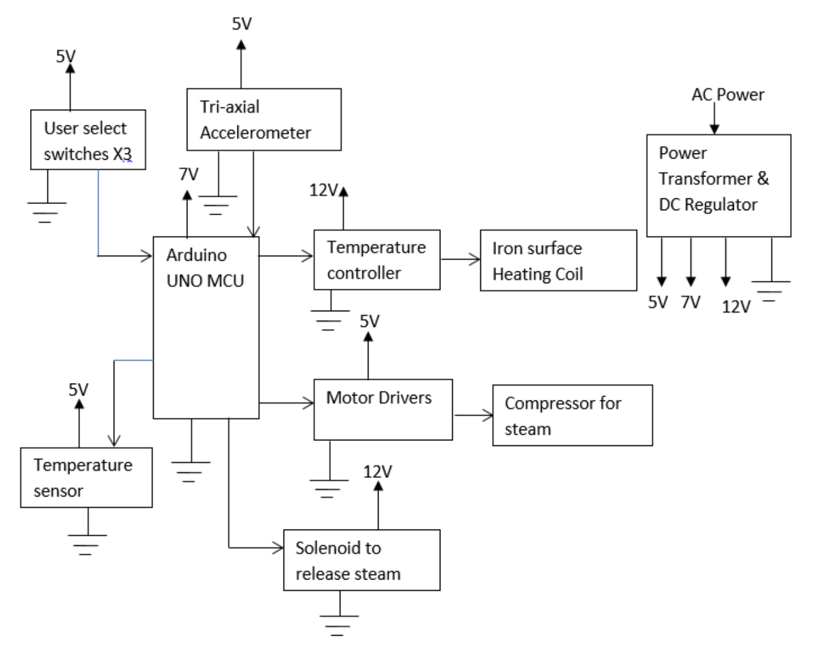

AY2019/20

Q4)

Arduino UNO MCU

Gnd

A0

A1

(3 marks)

b)

(i) d = v / 3.3 x (DH-DL) + DL

d1 = 2.5 / 3.3 x (20-0)+0 = 15.15m

d2 = 1.6 / 3.3 x 20 = 9.09m

width = d1 + d2 = 24.24m

There is no need to compensate for the distance apart of the 2 sensors because of the datum adjustment of –0.3m.

(7 marks)

(ii) Max Error ~ ± 5cm x 2 = ±10cm

(3 marks)

c)(i)

To set up D11 and D10 (or other digital pins) as software virtual Tx and Rx respectively.

Arduino UNO MCU

D11

D10

D1 / Tx

D0 / Rx

(6 marks)

(ii)

Arduino UNO MCU

A5 5V

A4 GND

pull-up resistors

SCA

SCA

SCL

SCL

(6 marks)

AY20/21

Q4.

1. Name 1 advantage of using a stepper motor over a DC motor in this application?

Advantage:

* No need for positioning sensor, hence lower cost and easier interfacing.

(2 marks)

1. There are two modes to drive the stepper motor: Two Phase Full Step or Two Phase Half Step. Discuss the comparative advantages of each of the driving modes.

Two Phase Full Step: Higher holding torque

Two Phase Half Step: Double the stepping resolution

(4 marks)

1. If Two Phase Half Step driving mode is used, what would be the minimum specification of the stepper motor in term of steps per revolution?

180 steps.

(2 marks)

1. If the only stepper motor available has only 50% of the required minimum stepping resolution, the technique of microstepping may be used to drive the stepper motor. Explain the working principle of microstepping.

Microstepping is a technique that achieves higher stepping resolution by controlling the fractions of current flowing into poles A & B individually, instead of using full current to energize the poles in the cases of all other driving modes.

(4 marks)

1. If a stepper driver is not available, we may interface the stepper motor with the MCU using 4 BUZ11 transistors as shown in Figure 3. Describe the sequence of turning the transistors ON and OFF to drive the stepper motor in Two Phase Half Step mode.

|  |  |  |  |  |
| --- | --- | --- | --- | --- |
| **Step** | **A (φ1)** | **B (φ3)** | **A’ (φ2)** | **B’ (φ4)** |
| 1 | On | On |  |  |
| 1.5 |  | On |  |  |
| 2 |  | On | On |  |
| 2.5 |  |  | On |  |
| 3 |  |  | On | On |
| 3.5 |  |  |  | On |
| 4 | On |  |  | On |
| 4.5 | On |  |  |  |

Step 1, 1.5, 2, 2.5, 3, 3.5, 4, 4.5, 1 … : CCW

Step 1, 4.5, 4, 3.5, 3, 2.5, 2, 1.5, 1 … : CW

(13 marks)

AY21/22

Q3.

1. Nyquist Theorem states that the sampling frequency has to be at least 2 times of the frequency of the signal to be measured. Since the temperature fluctuation frequency is 1 cycle per shift, the recommended number of recordings per shift is 2 or more times.

(3 marks)

1. Yes, white noise has uniform intensity over all frequencies.

(3 marks)

1. Software methods: (any 1)
   * Software Low pass filter
   * Averaging

Hardware methods: (any 1)

* Low pass filter
* Shielding connection wires

(4 marks)

1. (i) It is because the buffer tank is refilled every hour and hence measurement at A is not the real-time chemical consumption of the new line.

(3 marks)

(ii)

Arduino UNO MCU

Mass Flow Meter C

LPF

Mass Flow Meter A

LPF

(6 marks)

1. Advantages: (any 2)
   * Flexibility to implement different signal processing techniques
   * Lower hardware cost
   * Simpler circuit

Disadvantages: (any 1)

* Consume more computational resources of the MCU during run-time
* Input signals have worse Signal-to-Noise ratio

(6 marks)

AY22/23

Q4.

5V

7V

Camera Trigger x 2

Pedestrian Pushbuttons x 4

Traffic Lights x 2

Arduino UNO MCU #1

5V

5V

Pedestrian Lights x 4

RF module

12V

UART

Alarm (amplifier) x 2

7V

12V

Arduino UNO MCU #2

DC Motor x 4

DC Motor Drivers

5V

5V

AC-DC Convertor

12V

5V 7V

Power Mains

Pressure sensor x 2

LED Flashing lights x 2

(25 marks)